Terrarium With Plastic Flowers

Introduction

This article will show you how to make a terrarium with plastic plants.

Terrarium is sometimes made with real plants. However, those plants need care. Although looking after a terrarium made with real plants is not a difficult task, terrariums made with plastic plants are cheaper and do not require any care.

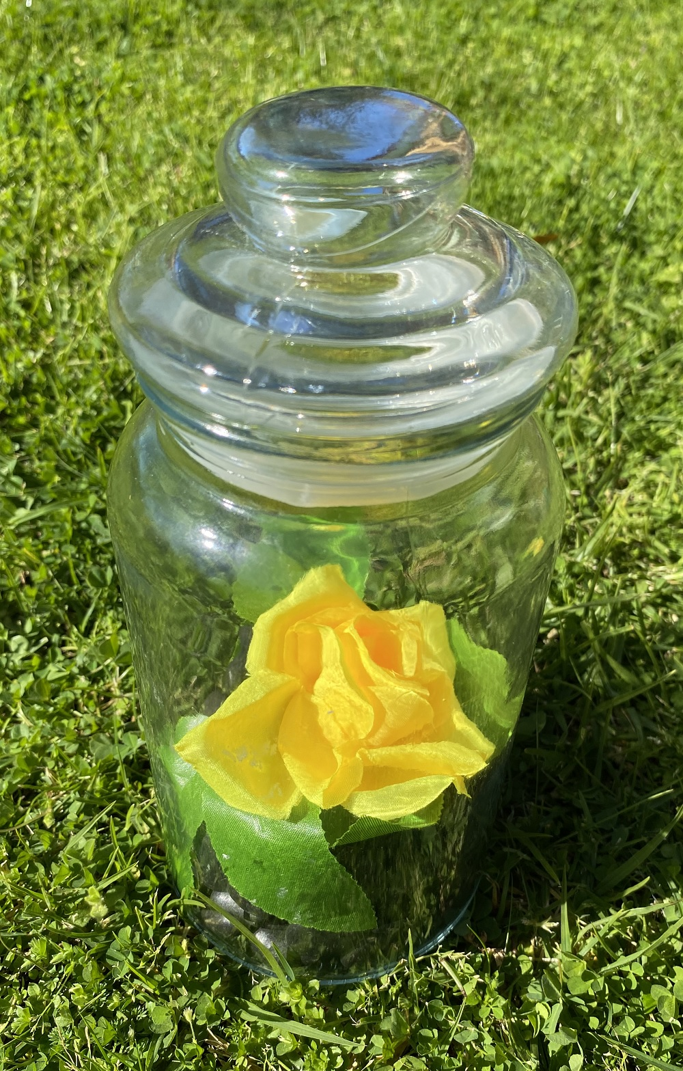
Figure 1: Terrarium With Plastic Plants.

Components and Tools

The total cost of components and tools is under $20 Australian or could be even less (because who does not have scissors at home?). You might need a stick or ruler that is not shown in the photos.

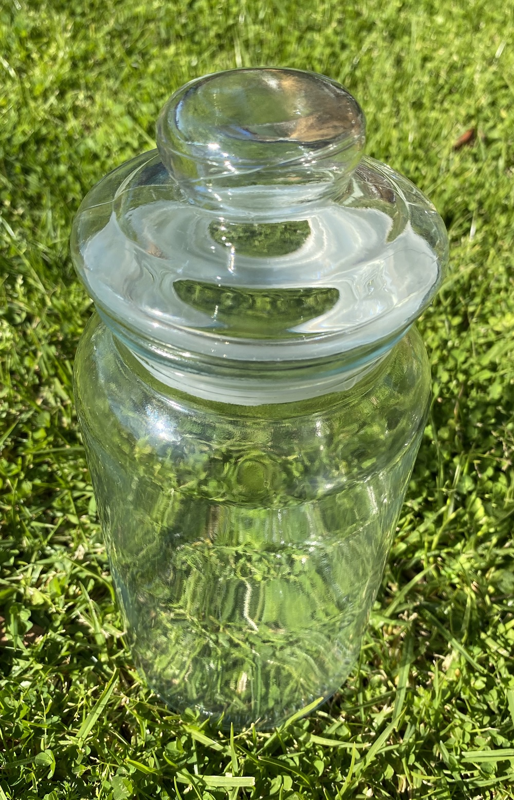 | 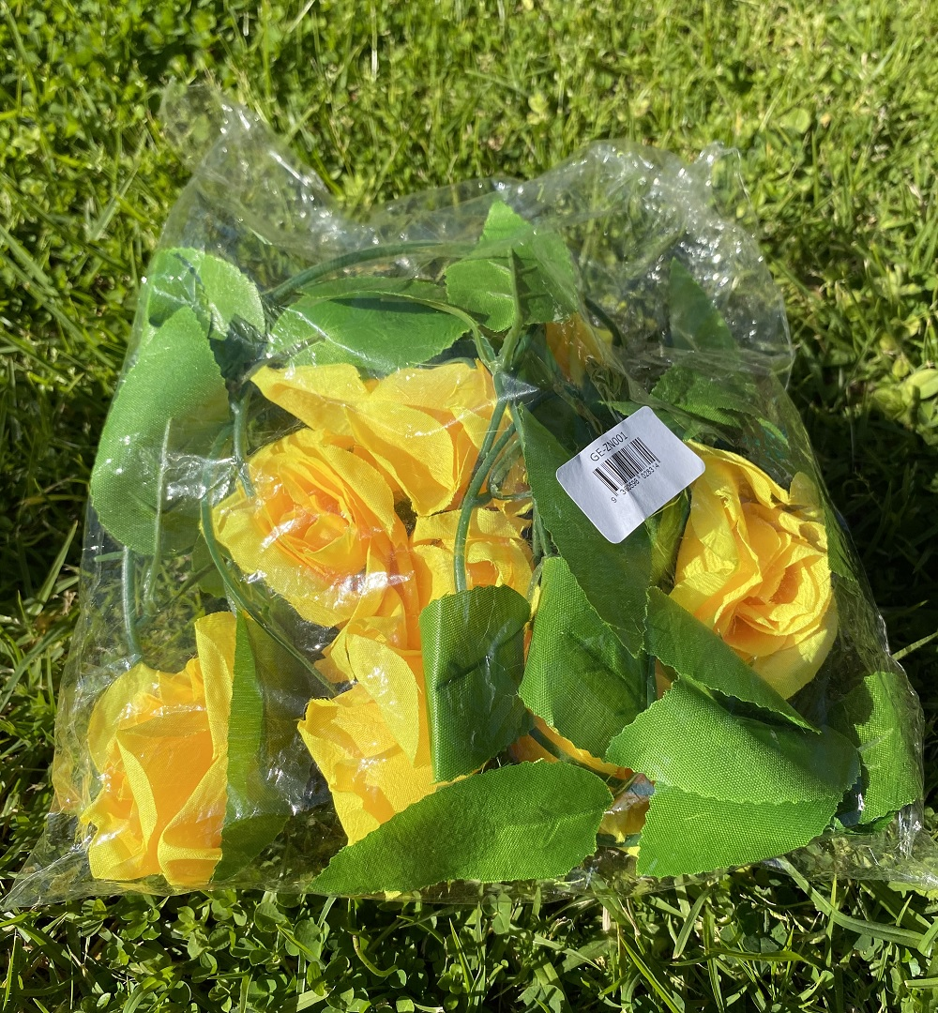
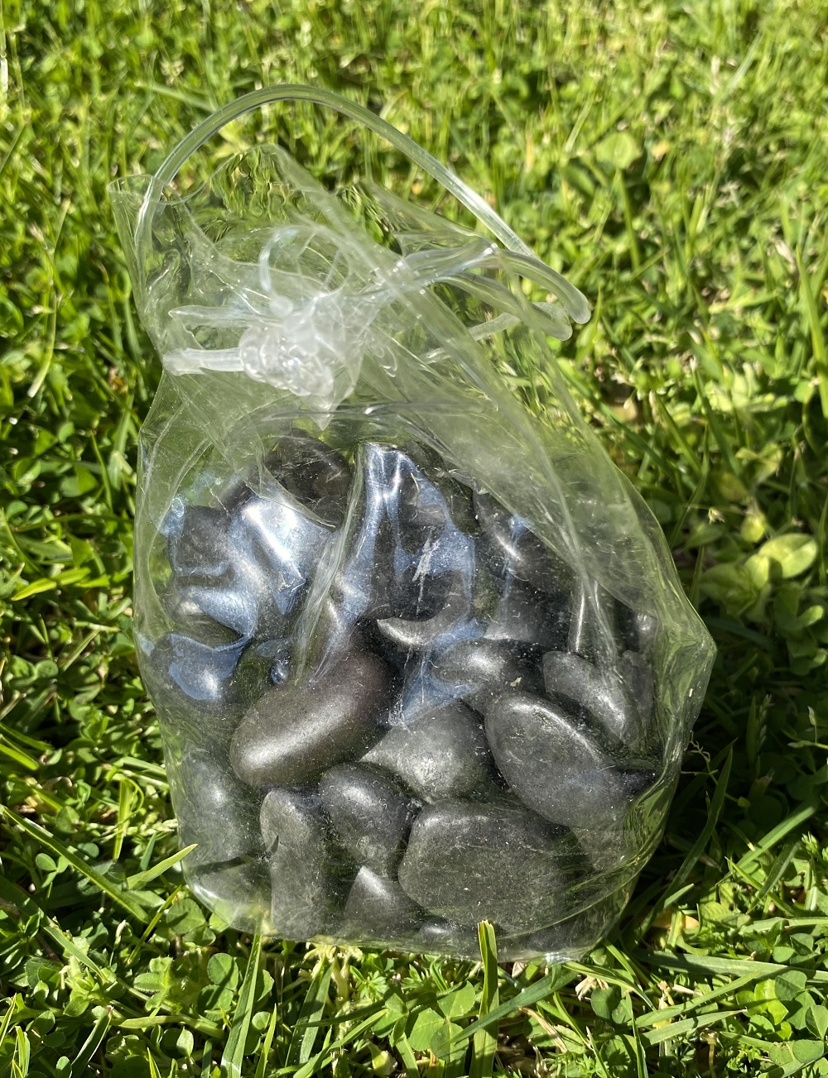 | 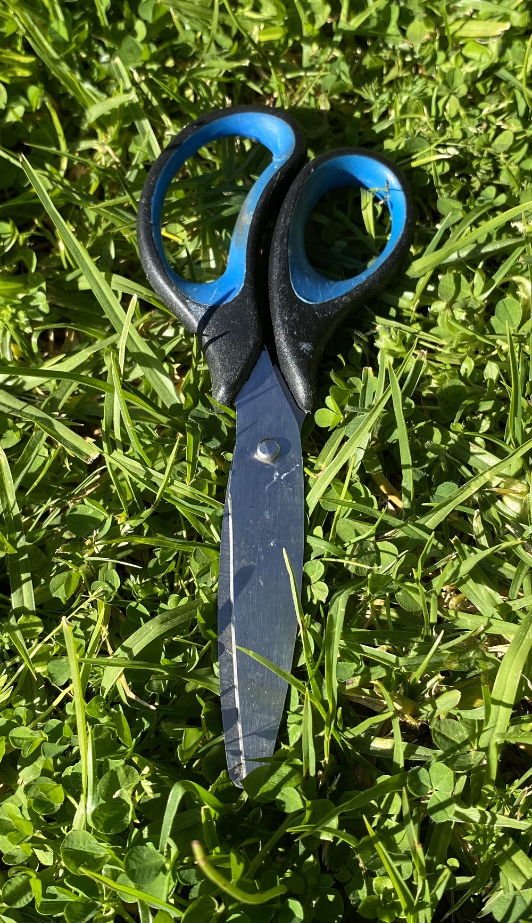
Figure 2: Components and Tools.

Step 1: Place the Stones Inside the Jar

You should not throw stones in the jar because the jar might crack or even break. You tip the jar to one side and carefully put stones inside the jar. Then place the jar upright and all the stones will fall to the bottom of the jar.

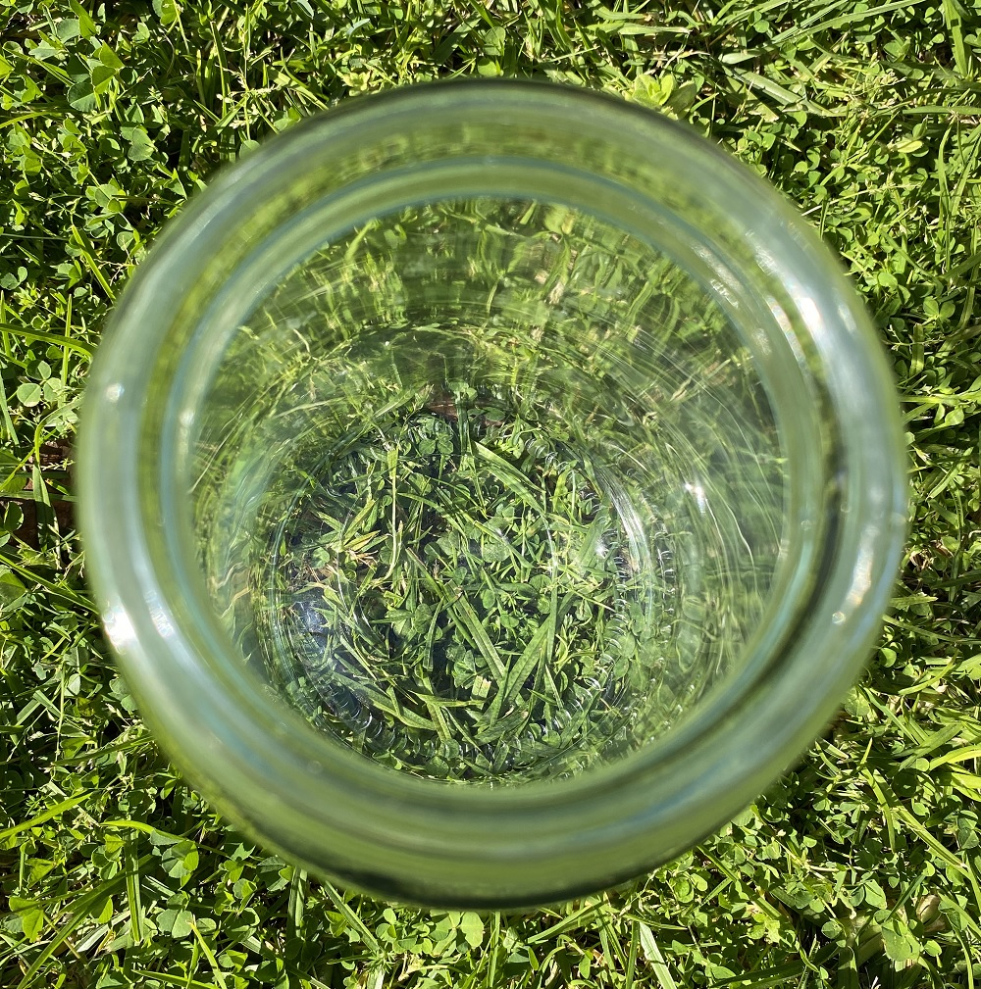 | 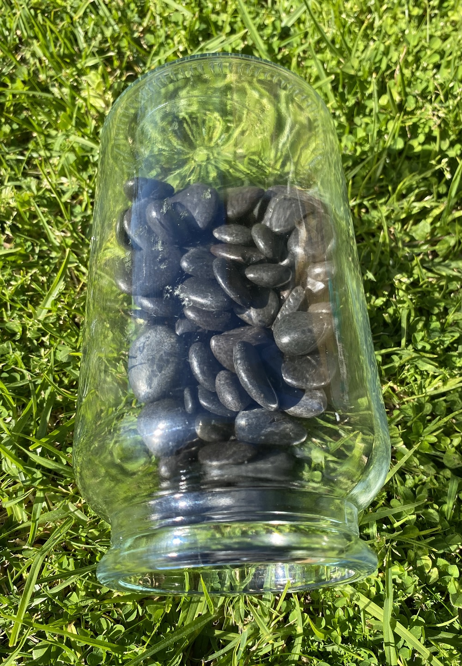
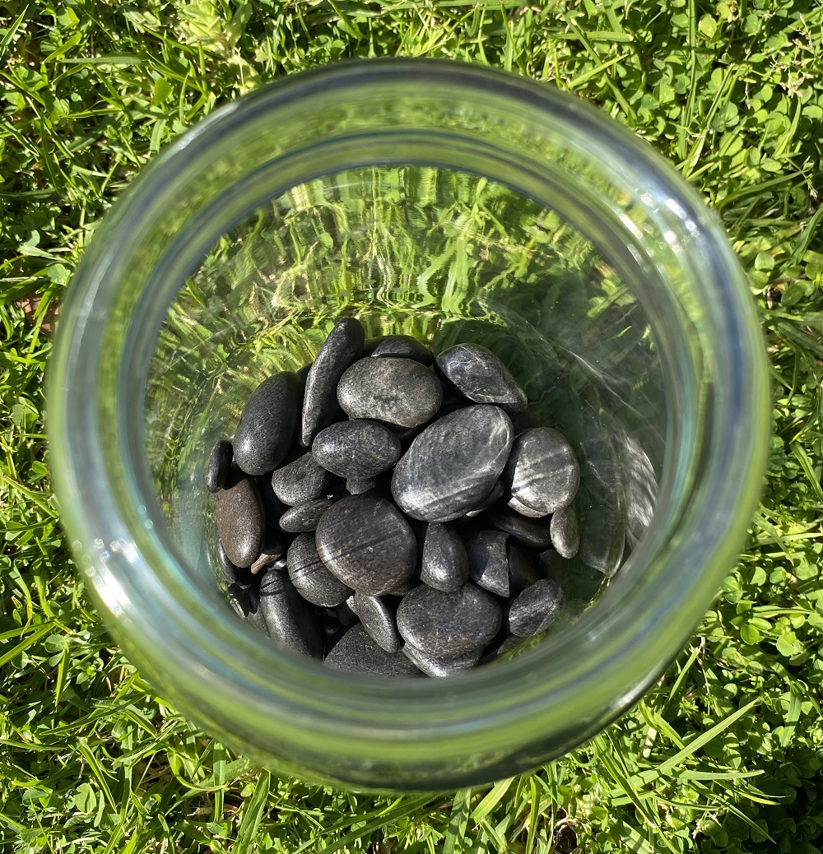
Figure 3: Place the Stones Inside the Jar.

Step 2: Cut the Flower

Use scissors to cut off one of the flowers from the plastic flower branch.

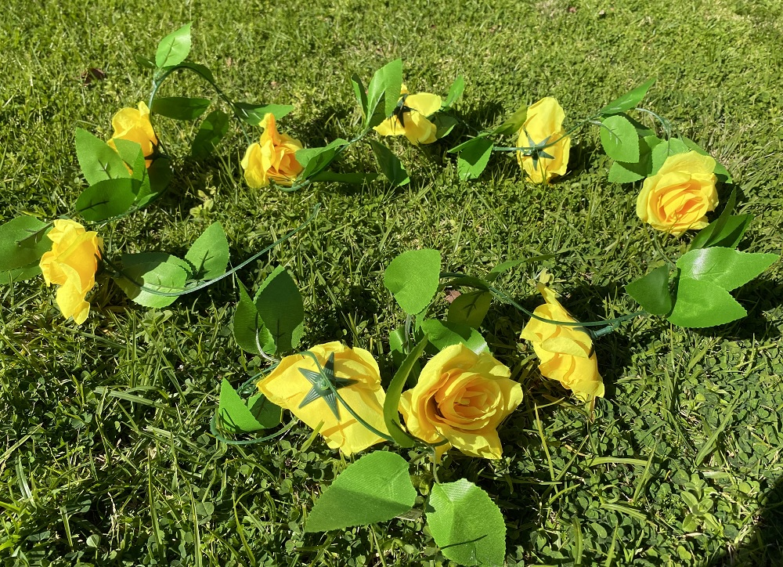
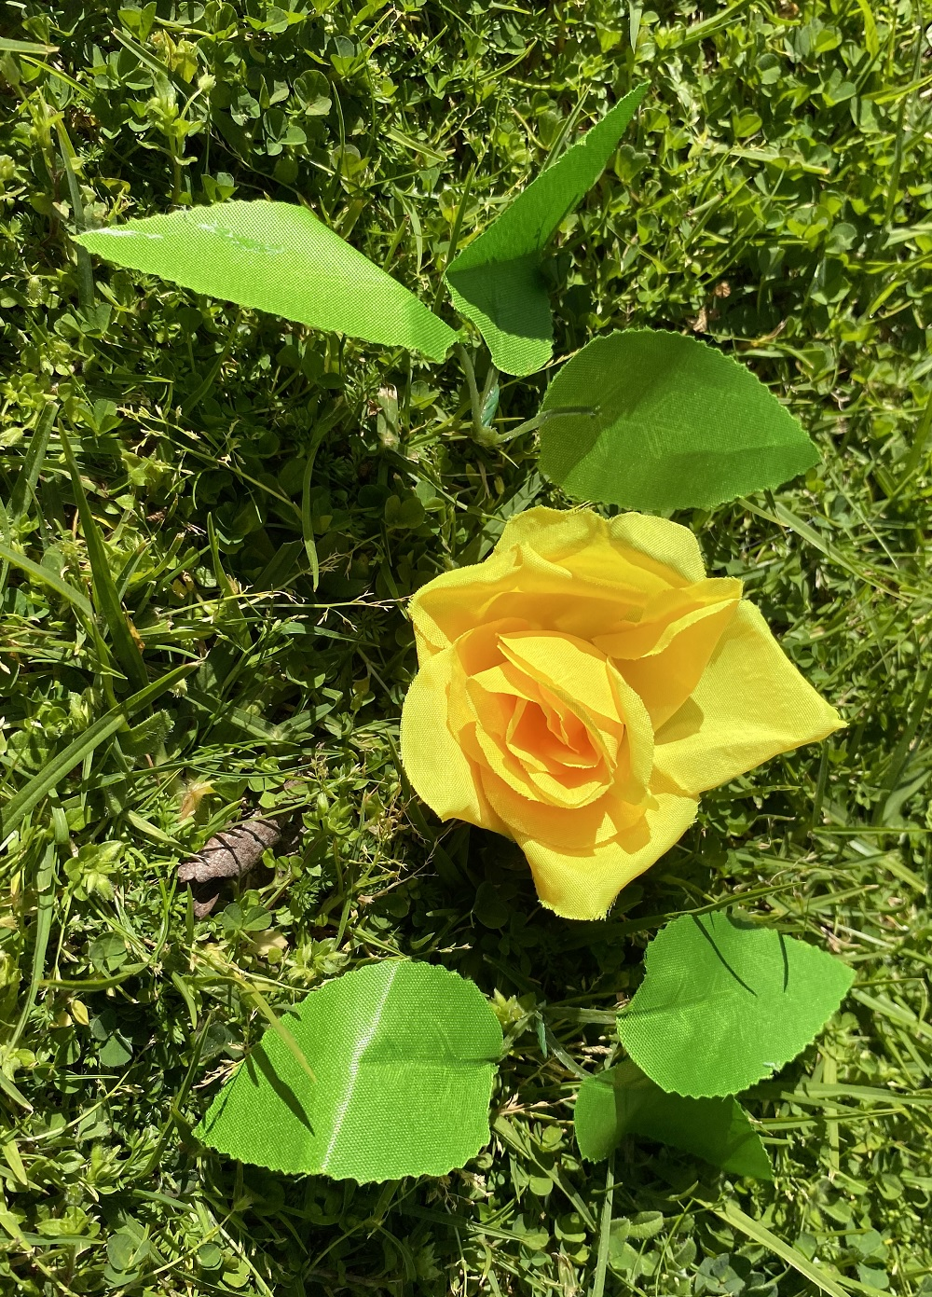
Figure 4: Cut the Flower.

You need to separate the flower from the leaves by cutting them off with scissors.

Step 3: Place the Leaves Inside the Jar

You do not need to put your hand inside the jar. If your hand does not fit inside the jar you can simply drop the leaves and move them with a stick or ruler.

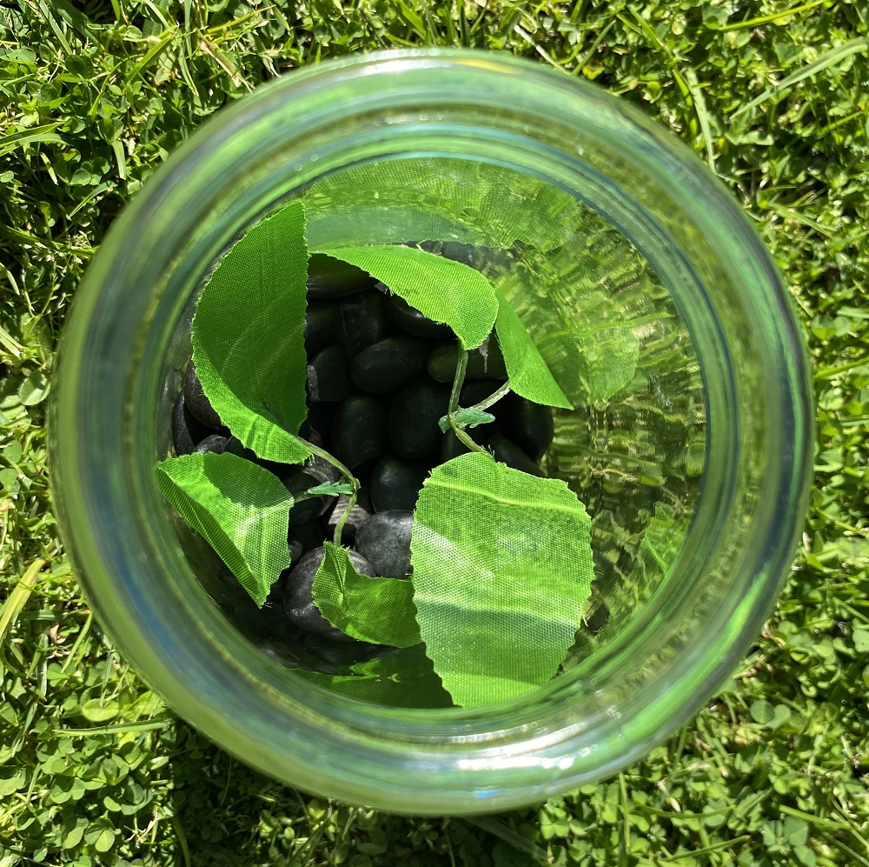
Figure 5: Place the Leaves Inside the Jar.

Step 4: Place the Flower Inside the Jar

Repeat the previous step for the flower:

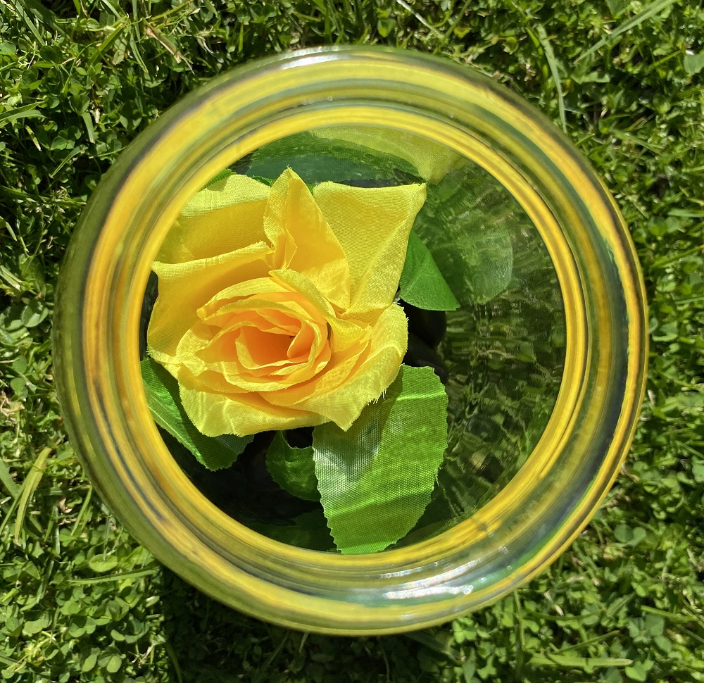
Figure 6: Place the Flower Inside the Jar.

Conclusion
Now you have a nice-looking terrarium that you can put on a table inside your room.

Andrew Box, Melbourne, Victoria, Australia

