Pom-Pom Snob

Introduction

This article is about making a cute doll out of pom-poms that I refer to as Pom-pom Snob.
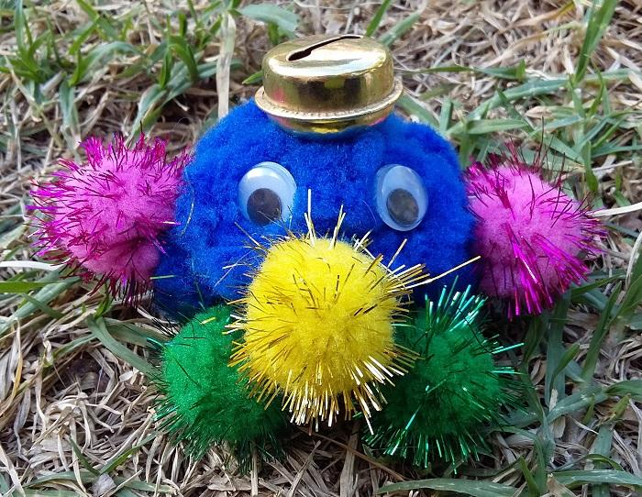
Figure 1: Pom-pom Snob.

Attaching arms, legs and the bell is like attaching a button to clothes.

2. Supplies
You will need:
- needle,
- thread (any colour - I chose white),
- scissors,
- one big pom-pom for the body,
- two similar pairs of small pom-poms for arms and legs,
- one small pom-pom for nose,
- bell that can be attached with a thread to the top,
- two plastic eyes,
- and craft glue (used only to attach the plastic eyes).
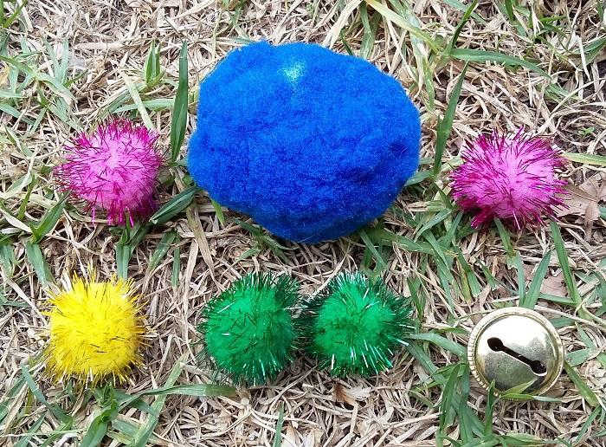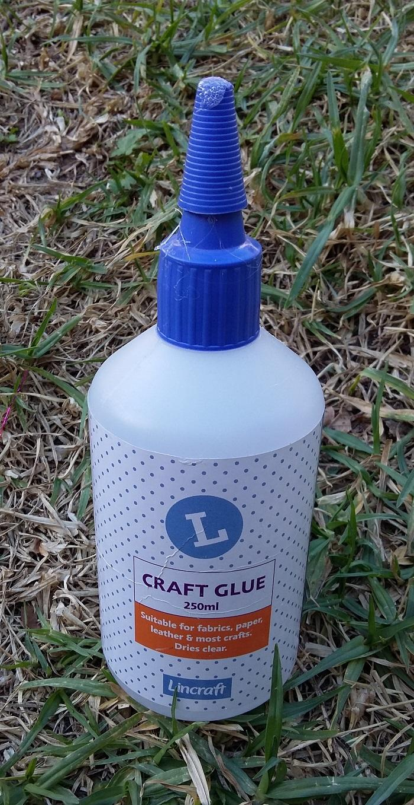
Figure 2: Items.

3. Step 1: Attach the First Leg

Cut 1 metre of thread, put through the needle, fold in half and tie a knot at the end.

Then put the needle through the big blue pom-pom and then through the small green pom-pom as shown in the first and second photos.

Put the needle through the knot as shown in the third photo.

Continue putting the needle through the blue and green pom-pom in a circle until the thread becomes short or is about the run out. Then tie a double knot or tie single knot twice as shown in the fourth photo.

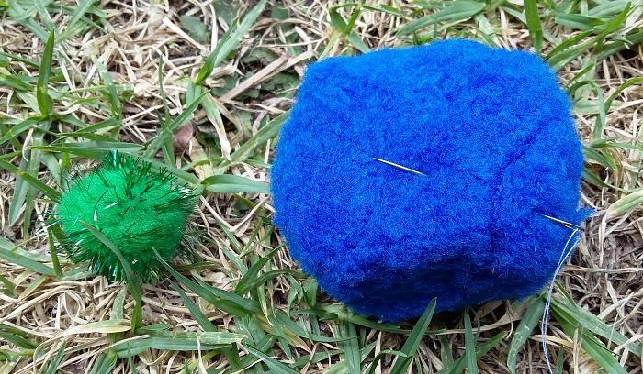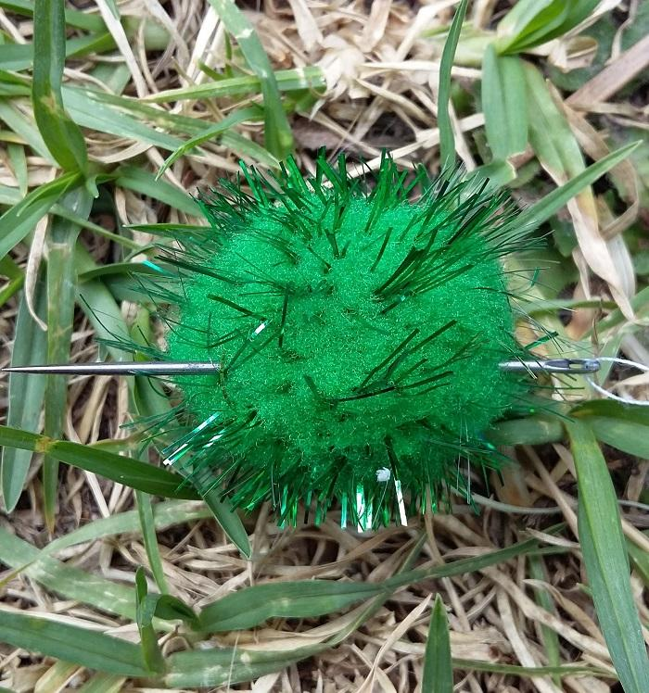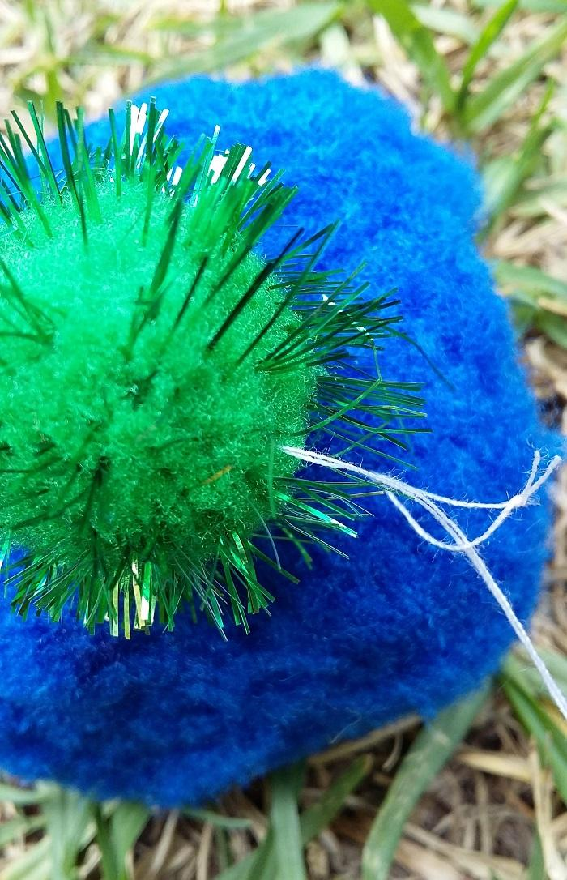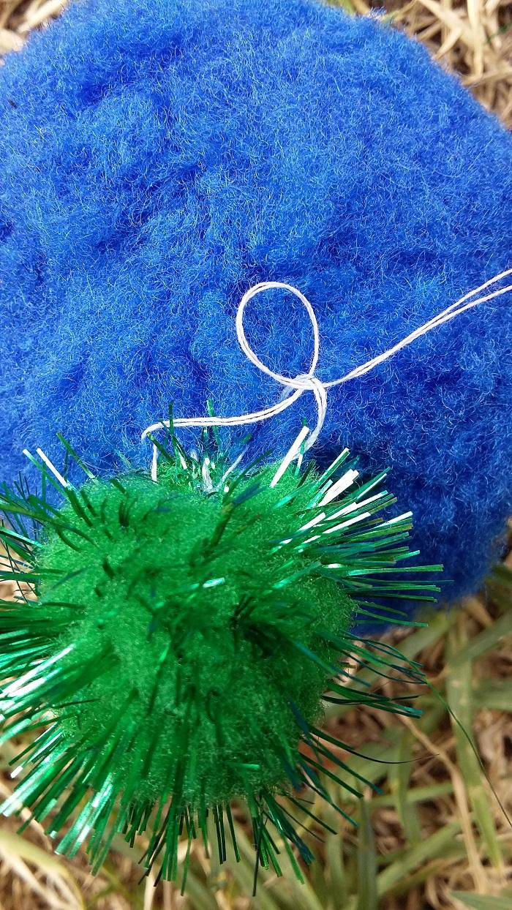
Figure 3: Attach the first leg.

4. Step 2: Attach the Second Leg

Repeat the previous step for the second leg.
Note the red circle in the first photo is showing where the thread should be.
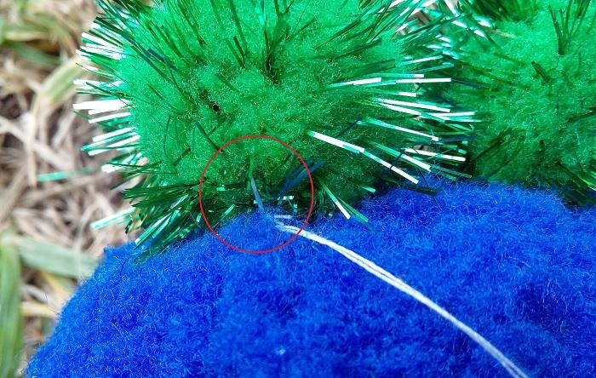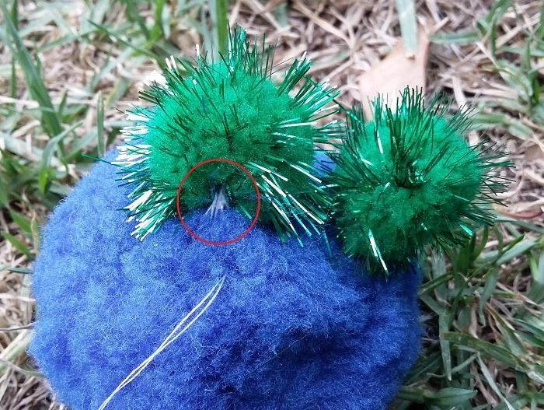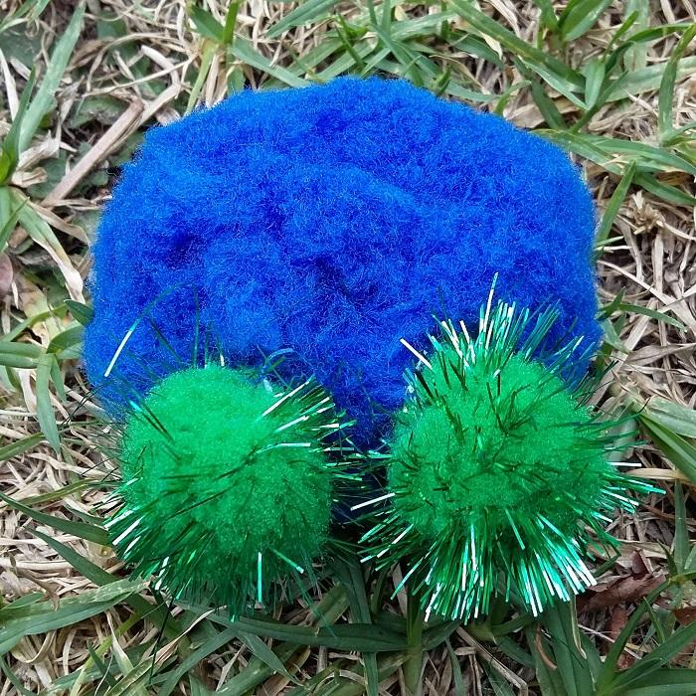
Figure 4: Attach the second leg.

5. Step 3: Attach the Nose

Repeat the step 1 for the nose.

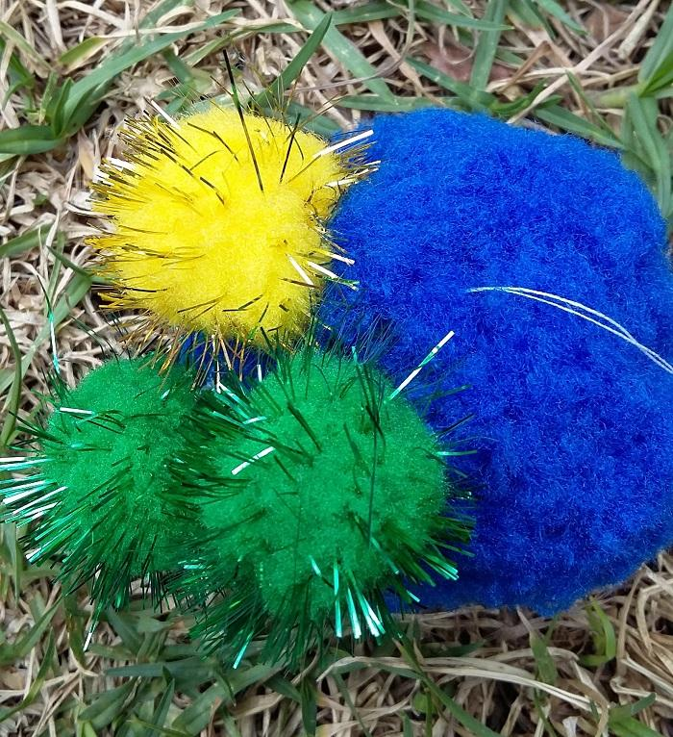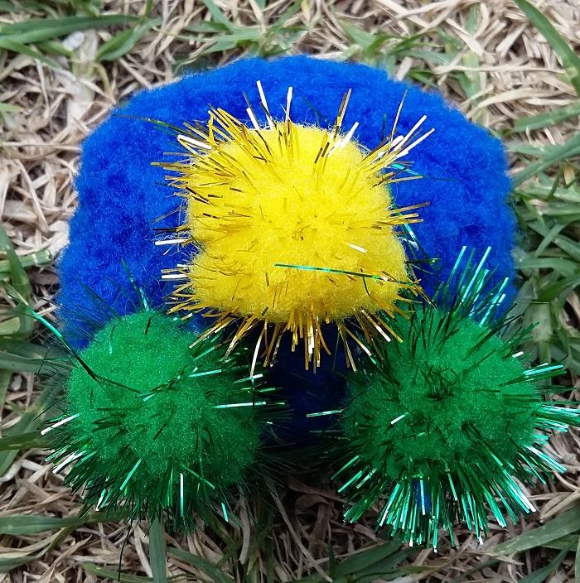
Figure 5: Attach the nose.

6. Step 4: Attach the First Arm

Repeat the step 1 for the first arm.
Note the red circle in the first photo is showing where the thread should be.

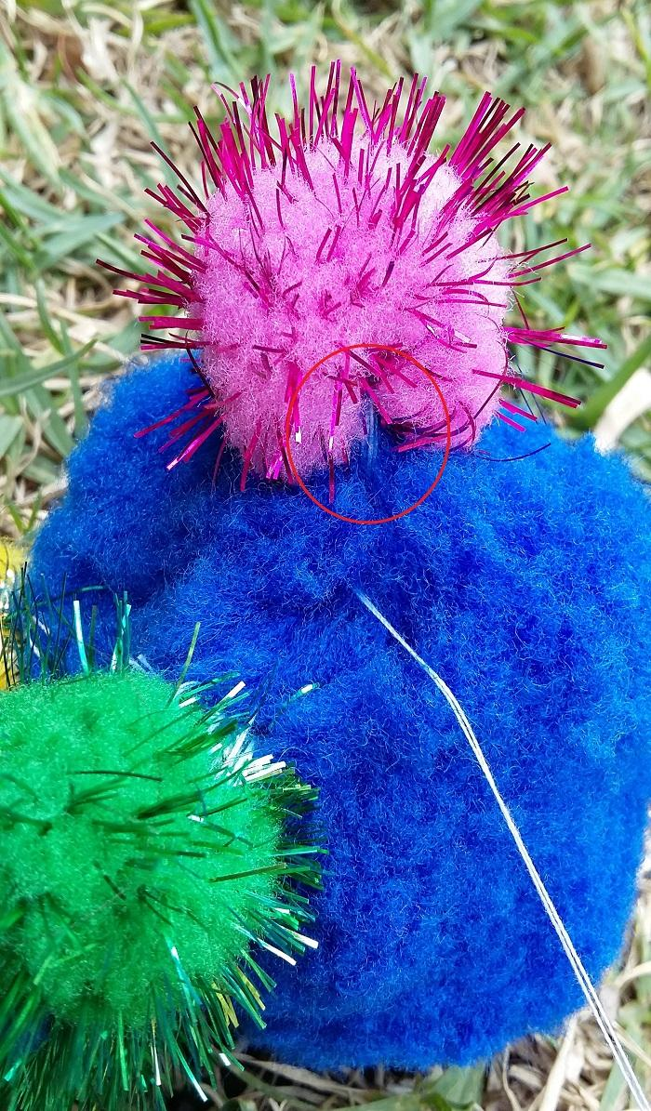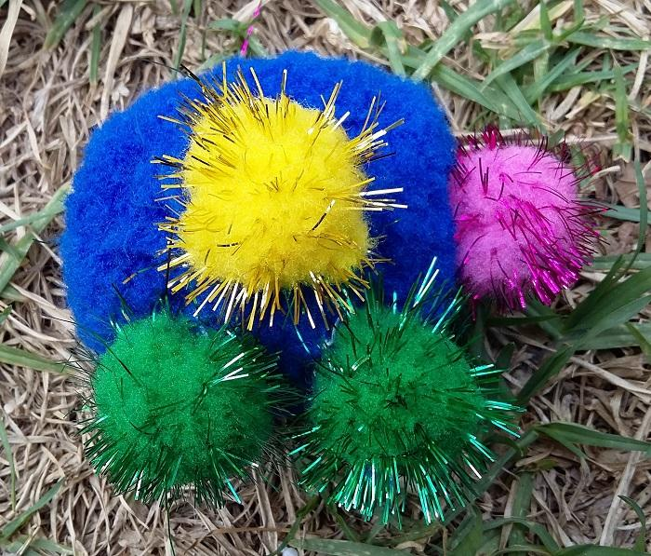
Figure 6: Attach the first arm.

7. Step 5: Attach the Second Arm

Repeat the Step 1 for the second arm.

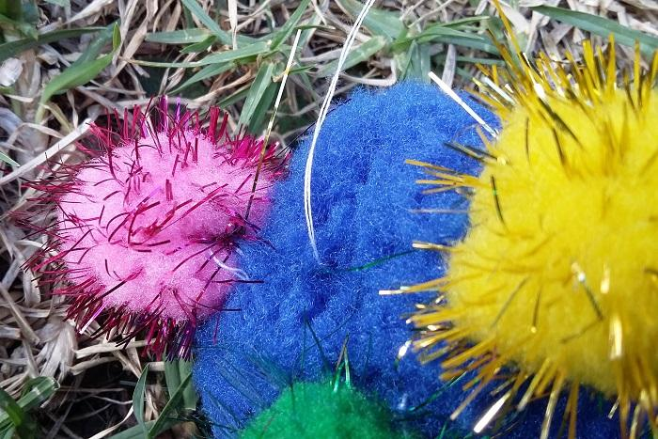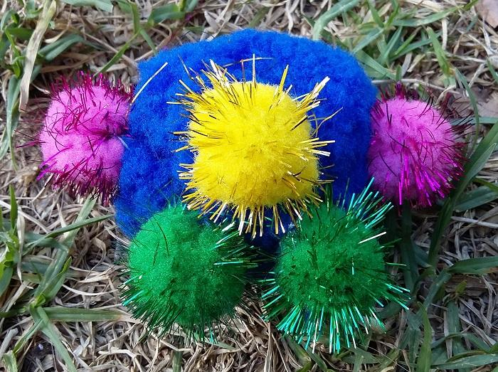
Figure 7: Attach the second arm.

8. Step 6: Attach the Bell

Cut 1 metre of thread, put through the needle, fold in half and tie a knot at the end.
Then put the needle through the big big blue pom-pom and then through the opening in the bell as shown in the second photo.

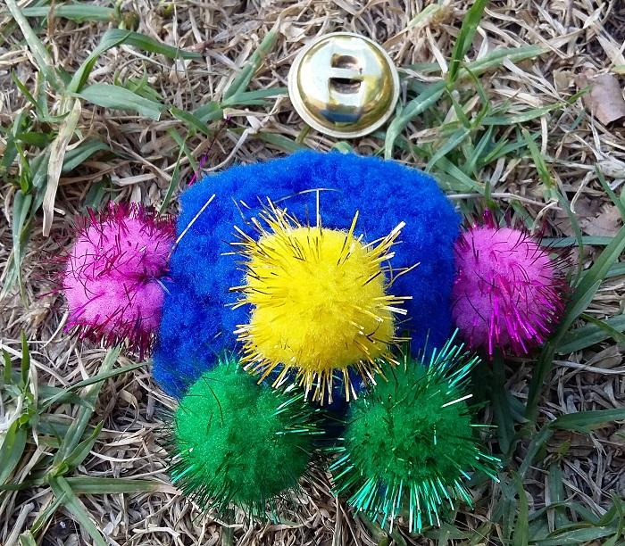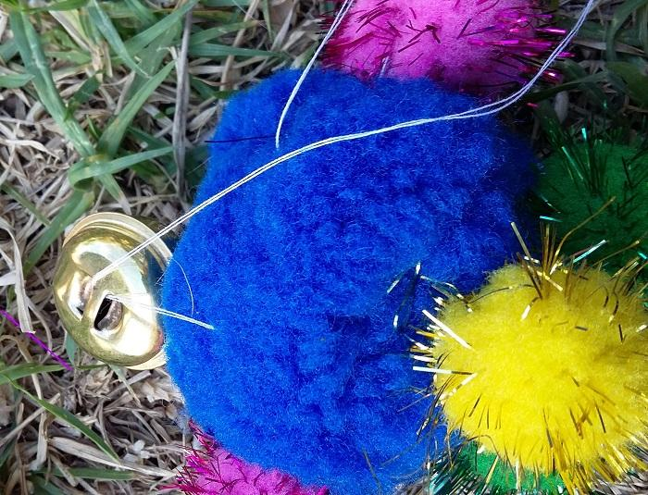
Figure 8: Attach the bell.

Put the needle through the knot as shown in the third photo.
Continue putting the needle through the big blue pom-pom and opening in the bell in a circle until the thread becomes short or is about the run out. Then tie a double knot or tie single knot twice.

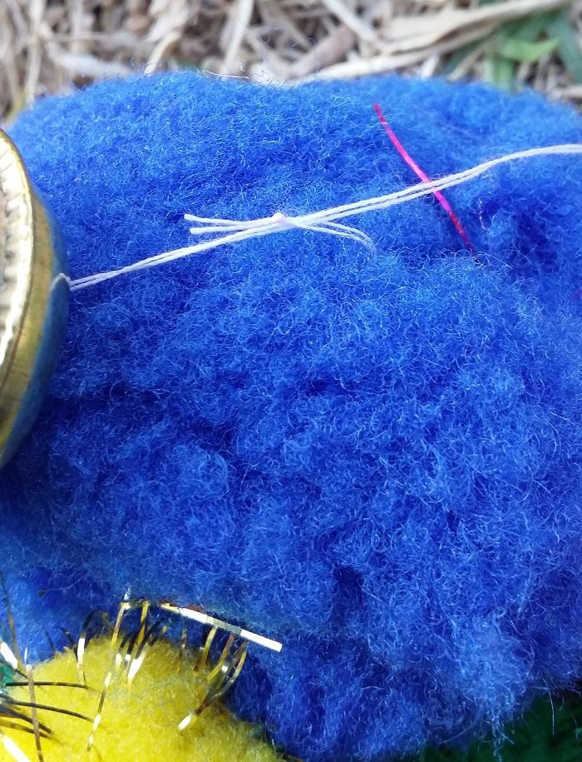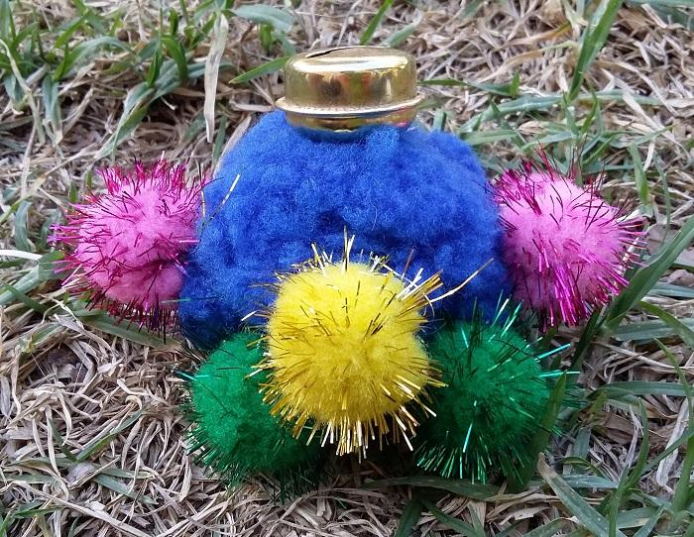
Figure 9: Attach the bell.

9. Step 7: Attach the Eyes

Put craft glue on the plastic eye as shown in the photo (do not put any glue on the big blue pom-pom).
Then attach the eye to the big blue pom-pom and press hard (not hard enough to deform the plastic eye) for a few seconds.
Repeat this step for the second eye.
Leave to dry for 24 hours and you are done.

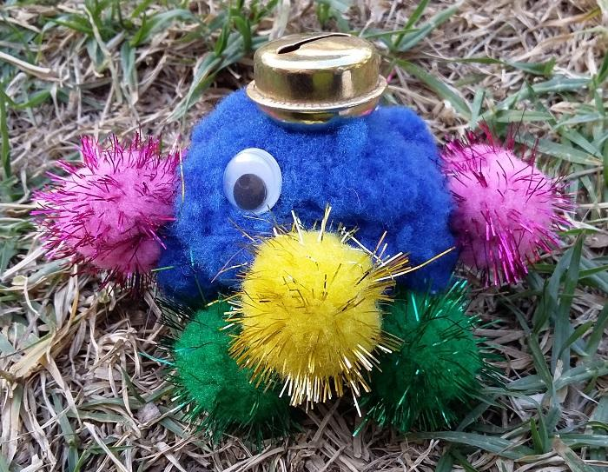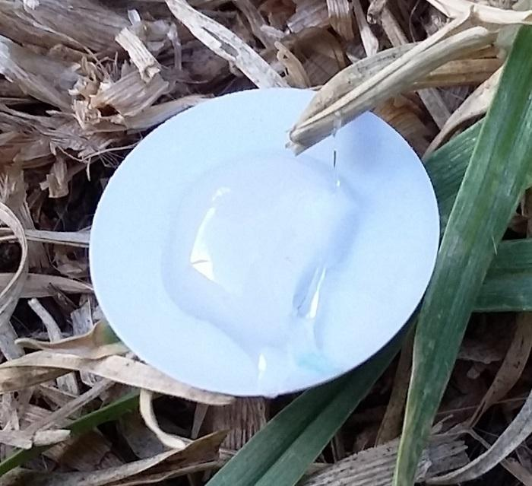
Figure 10: Attach the eyes.

Figure 11: Compete toy.

